Durham Region Library: User Manual

By Francis Hackenberger & Frederick Carbonneau

Final database project

DBAS 1201

December 1rst, 2014

Table of Contents

Revised Problem Definition 2

The tables 3

Books table 3

Customer table 3

Employee table 4

Events table 5

Job information table 5

Order information table 6

Orders table 6

Organization table 7

Participating table 7

The queries 8

Books by author query 8

Books in stock query 9

Books not returned query 10

Event participation query 11

Total late fees query 11

Upcoming events query 12

The forms 12

Books form 12

Organisation events form 13

Upcoming events form 13

Navigation forms 14

The reports 14

Customer Late Fees report 14

Upcoming events report 14

Relationships report 15

Project Rubric 15

# 

# Revised Problem Definition

We will be creating a library system database to help better manage and track information on the library’s events, members, books, and orders.

The queries we intend to create will include tracking books that haven’t been returned, books that are currently in stock, find all books with a specific author, find upcoming events, display who is participating in which events, and finally a query to calculate the total late fees accumulated by each customer. These queries will be beneficial to the library database because it will allow users to more easily find important information that needs to be retrieved for a customer in a timely manner and to determine if they need to contact a customer that has a book overdue and that have fees that are accumulating.

Furthermore, we plan to establish forms such as, a form to display books as well as their book covers with all other information regarding the category the book belongs to as well as have the capability of adding new records (Books) into the database. Additionally, we will include a form to sign up for upcoming events. Our database will also include a form created for the organizations utilizing the database where they can add events of their own and input information for example, the date, time, event description, etc. Finally, there will be a fully functioning navigation menu form where users can navigate the form easily while keeping information that they would not be authorized to see. The preceding forms will serve an important purpose by allowing users to quickly navigate the database for meaningful information.

Finally, the reports we expect to generate will display a summary of the databases data. For instance, expose the total late fees for each customer (if they have any fees due), display upcoming events that will take place in a certain time period in order to keep track of time restrictions, and a report that will present the tables relationships to easily view the joins between records and simultaneously restricting the users from modifying, or tampering with the relationships.

# The tables

## Books table

The books table organizes the information concerning all the books in the library’s database. Any information regarding books can be traced back by its ‘Book ID’ which is used as the primary key of the table in order to link the table with other tables.

### Datasheet view

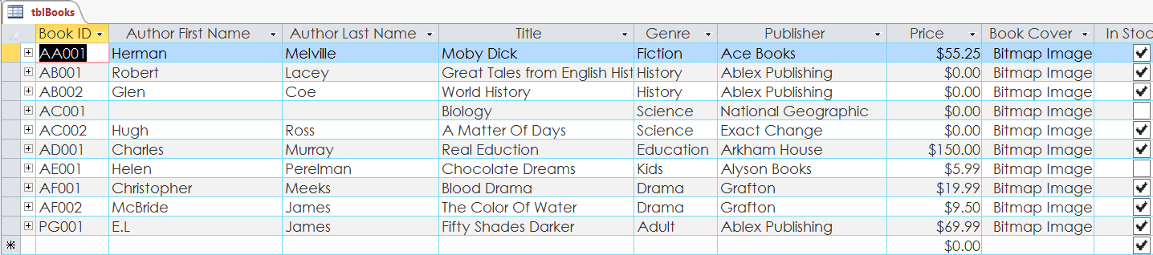

### Design view

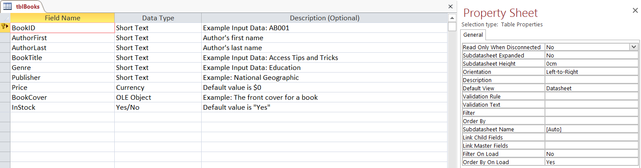

## Customer table

The customer table’s primary key is the ‘Customer ID’ field, it’s primarily used to link the order information back to the customer that made the order. It also links with several other tables including the events table and multiple queries.

### Datasheet view

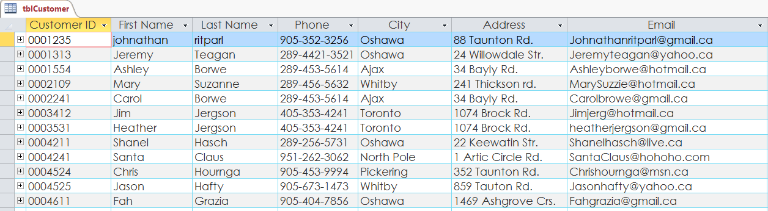

### Design view

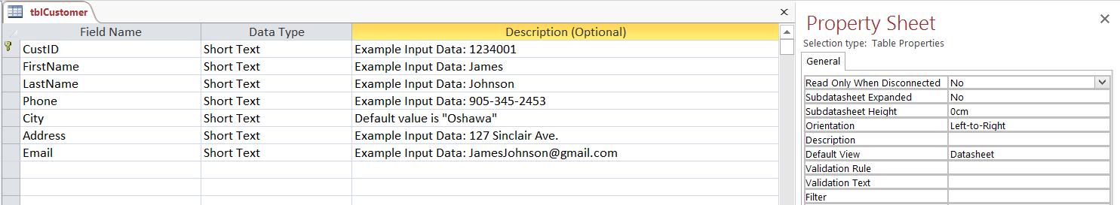

## Employee table

The employee table stores information concerning the employee’s working at the library. The ‘Employee ID’ field being the primary key. Each employee has a ‘Job ID’ which is used to determine that employee’s job title or description by tracing it back to the linked job information table.

### Datasheet view

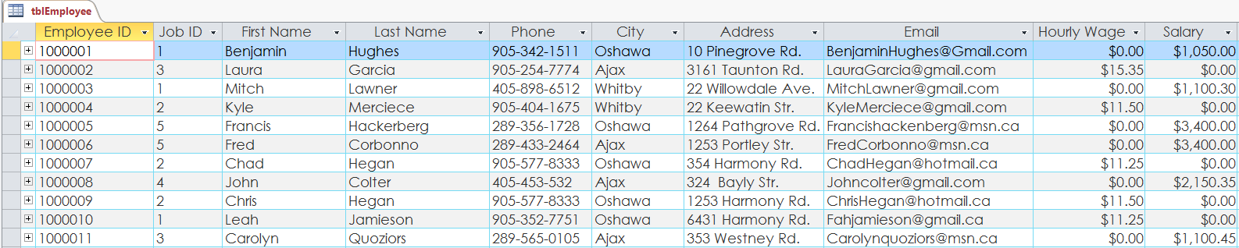

### Design view

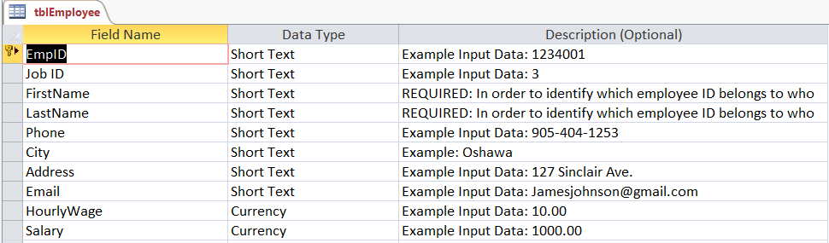

## 

## Events table

Durham Region Library hosts many events and keeping track of the dates, times, entry fees and other factors is important to stay organized. The event table’s primary key is the ‘Event ID’ field which is primarily used to link the organization hosting the event in the organization table. Events can range from reading clubs, to birthday parties, and even business meetings or library tours.

### Datasheet view

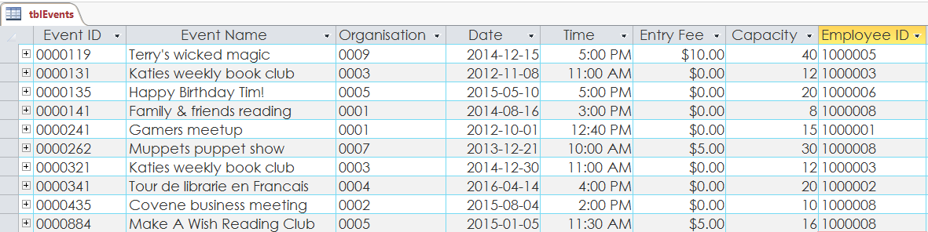

### Design view

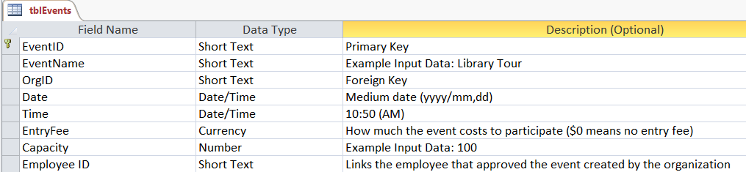

## Job information table

The job information table is strictly used to identify the job title/description of each employee by linking the ‘Job ID’ to the ‘Job ID’ found in the employee table.

### Datasheet view

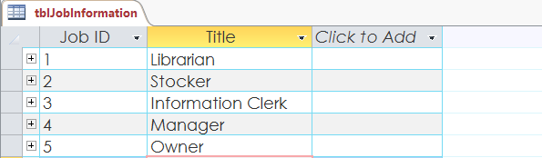

### Design View

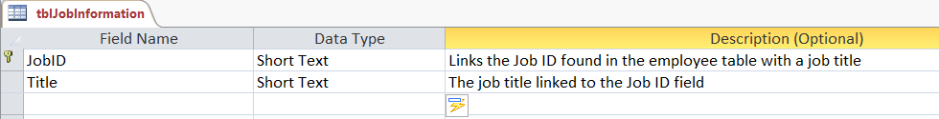

## Order information table

The order information table holds most of the information pertaining to a customer’s book(s) order. The table’s primary key being the ‘Order ID’ which is linked the orders table (contains other information for example: book ID). The customer ID is used to track customer information in need of contact or billing.

### Datasheet view

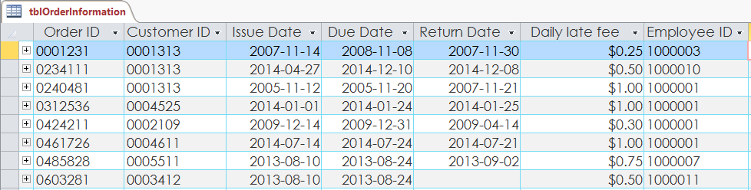

### Design view

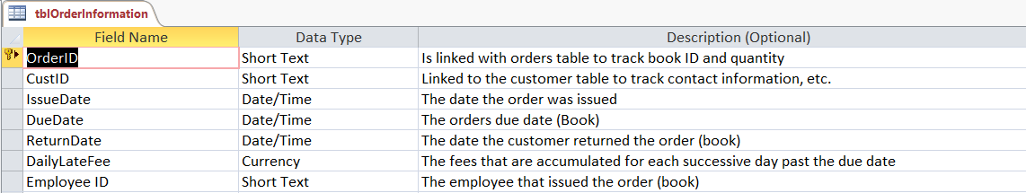

## Orders table

The orders table is an extension of the order information table, it contains two primary keys, ‘Order ID’ and ‘Book ID’. It’s used to store which books and how many of them were issued for each order.

### Datasheet view

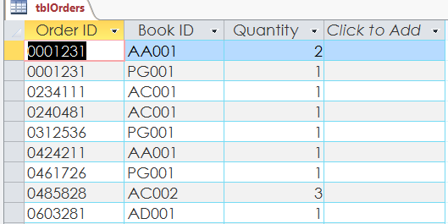

### Design view

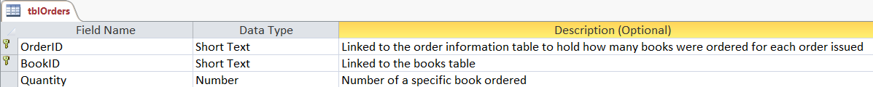

## Organization table

Tracks each organizations information, such as ‘Name’, ‘Phone Number’, and ‘Email’. The primary key being ‘Organisation ID’ which is linked to the ‘Events Table’.

### Datasheet view

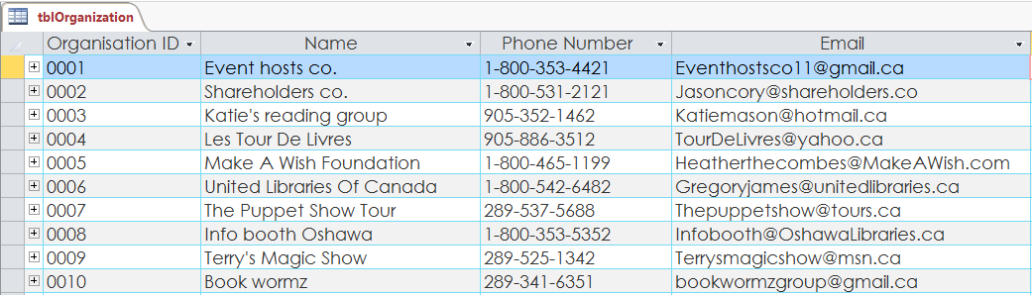

### Design view

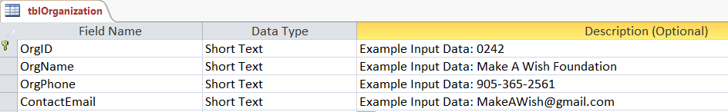

## Participating table

A relatively small table in comparison to the others presented; stores the ‘Customer ID’, ‘Event ID’, and ‘Paid Fee’ fields. The two primary fields being ‘Customer ID’ and ‘Event ID’ are used to track the events and how many members have verified that they will be participating. The ‘Paid Fee’ field is used to determine if the customer has paid the entry fee for that specific event.

### Datasheet view

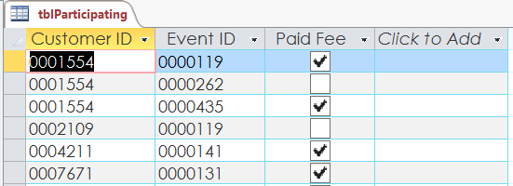

### Design view

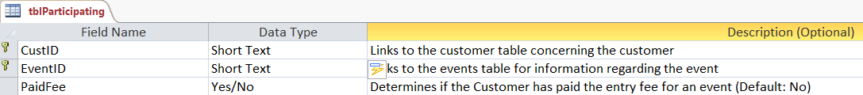

# The queries

## Books by author query

This parameter query is used by searching for books by a specific author. For example: to search for all books by E.L James, type the full name in the parameter search bar and the list will be generated.

### Datasheet view

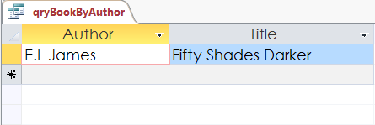

### Design view

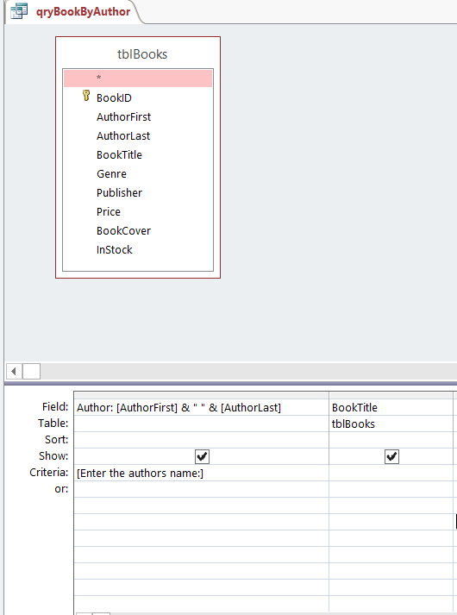

## Books in stock query

This query generates a list of all books in stock; listing the ‘Book ID’ and the ‘Title’ fields. It pulls information from the Books table and displays all books that are marked as ‘True’ in the criteria from the ‘In Stock’ field.

### Datasheet view

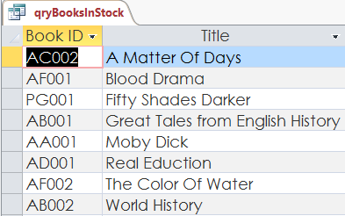

### Design view

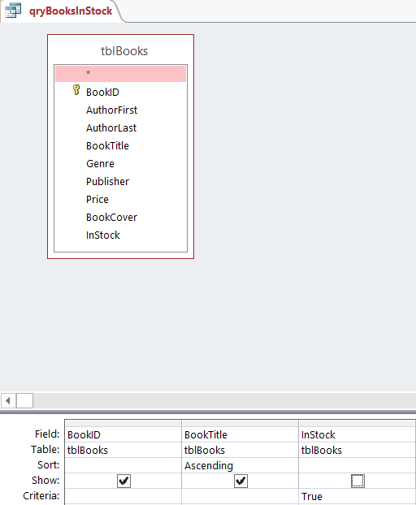

## Books not returned query

The books not returned query displays all books that have yet to be returned or are missing a return date from the Order information table. The query utilizes two tables: ‘Order Information’ and ‘Orders’ to retrieve the issue date and due date as well as customer ID, order ID and the Book ID.

### Datasheet view

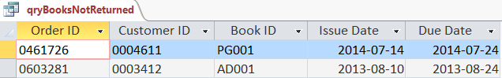

### Design view

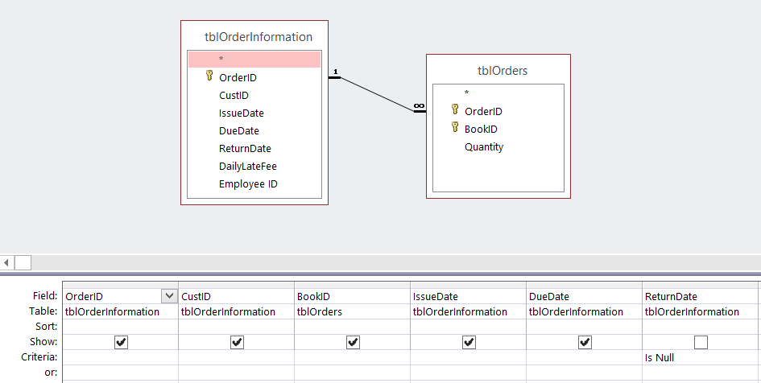

## 

## Event participation query

The following query uses the ‘Total’ function ‘Count’ in which it counts all the customers participating in a specific event and displays the total. The query also shows the events capacity and event ID. This query is useful for keeping track of how many customers are participating in a specific event in order to ensure that it doesn’t go over the maximum capacity.

### Datasheet view

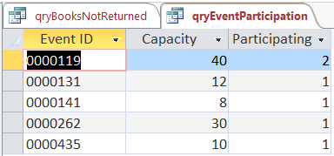

### Design view

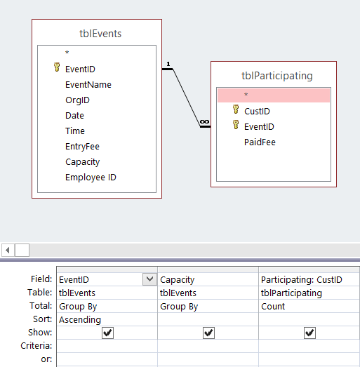

## Total late fees query

This query is extremely useful in the sense that it calculates the total late fees accumulated by each customer (excluding customers that have no late fees) and also displays the return date of that order as well as the customer ID and order ID. The total late fee is determined by calculating the daily late fee times the date difference in days between the due date and return date of that order.

### Datasheet view

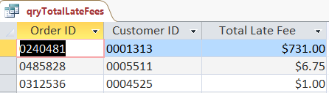

### Design view

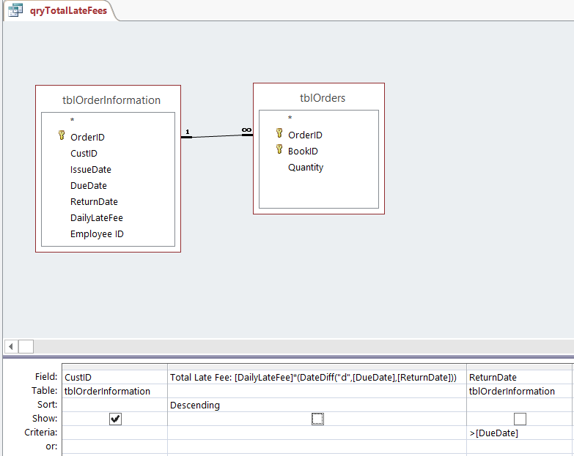

## Upcoming events query

This query displays all upcoming events as well as their date, time, event name and event ID. Upcoming events are determined by pulling all events that have a date later than the current date (>date()).

### Datasheet view

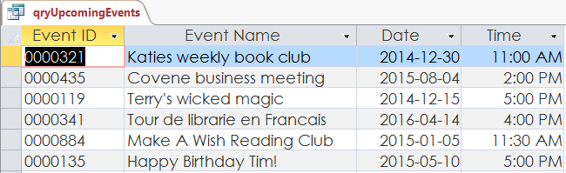

### Design view

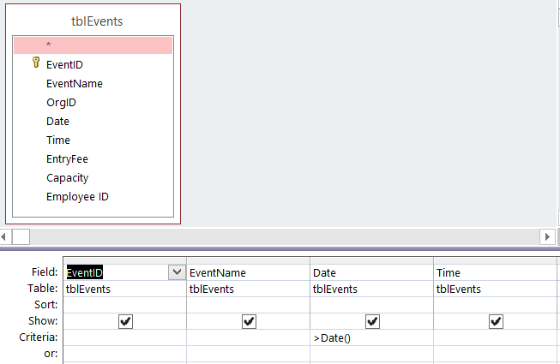

# The forms

## Books form

The books form allows the users to navigate the form by clicking on the forward and backwards buttons as well as add a book by clicking the ‘Add Book’ button. The form features all of the information that can be found in the books table (Datasheet view) in a more organized fashion. It also displays the book cover for each book.

### Form view (output)

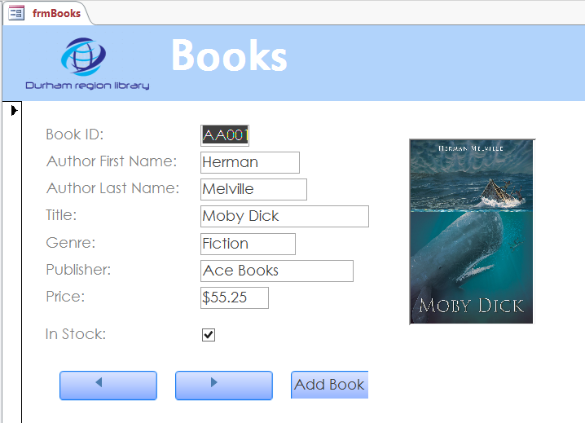

## Organisation events form

This form is designed for organisations to manage and create events by filling out the events sub form after they’ve entered their ‘Organisation ID’ and ‘Name’. This form is useful in the sense that it displays a simple and interactive interface that virtually anyone could use. It features a next and previous button on the form to navigate to different organisations and their respective events as well as add event button.

### Form view (output)

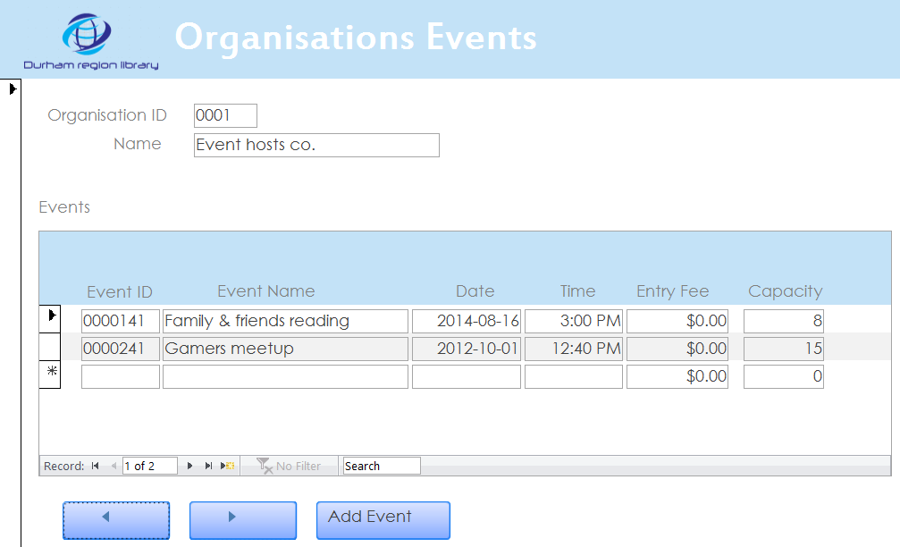

## 

## Upcoming events form

The following form is simply for navigating the upcoming events using the ‘Upcoming events’ query. It has a next and previous button in order to easily navigate through the different events. The form displays the important information regarding the events such as: Event ID, Event Name, The date, the time, entry fees and the capacity.

### Form view (output)

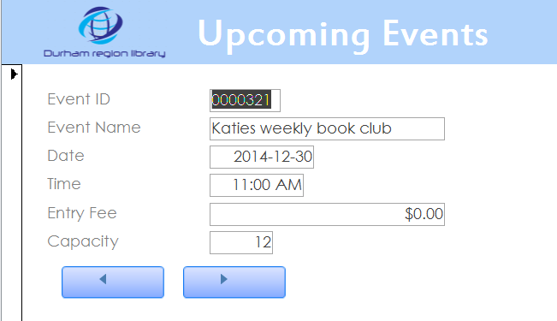

## Navigation forms

The most important element of the user friendliness of the Durham Region Library’s database is thanks to multiple navigation forms combined into one main navigation menu. This is the form that will be opened by default for users to interact with in which they will be able to open the databases tables, queries, forms, and reports. The menus buttons utilize macros in order to open the table, query, form, or report.

### Form view (output)

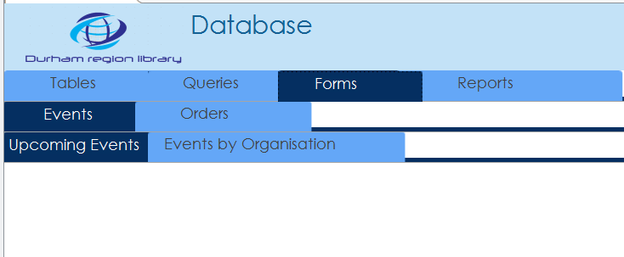

# The reports

## Customer Late Fees report

This report displays the total late fees for each customer and shows all of their important information such as: First name, Customer ID, Order ID and phone number. Each customer is sorted by their last name for organizational purposes.

### Report view (output)

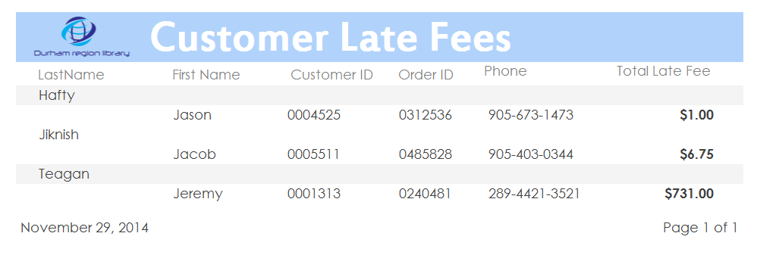

## Upcoming events report

The second, and last report is the upcoming events report. It features the event name, the event ID, the date, and time. The report to be primarily used for handing out to customers, or other employees.

### Report view (output)

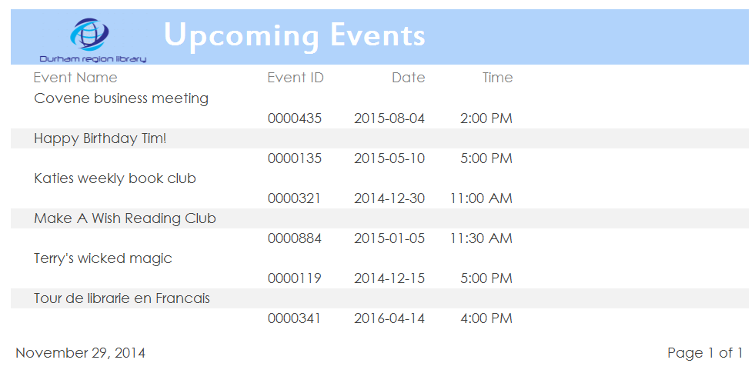

## Relationships report

Finally as an added report, we have the table relationships report so that users or administrators can view all the relationships between the tables in an organized manner as well as being protected from any modification from the actual relationships live on the database. (This is to avoid any manipulation of the relationships which could potentially break the database).

### Report view (output)

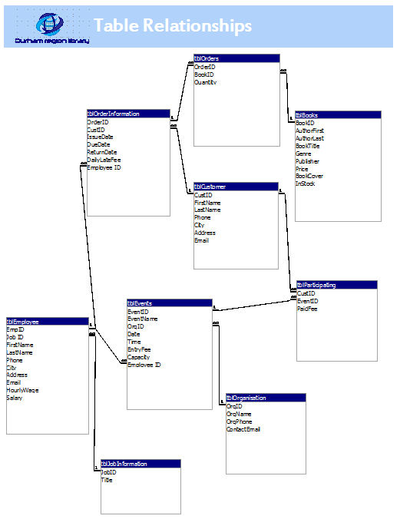

# Project Rubric

|  |  |  |  |
| --- | --- | --- | --- |
|  | | **Out Of** | **Achieved** |
| **BASIC REQUIREMENTS** | |  |  |
| 1. | Database contains at least 4 tables | **2** |  |
| 2. | Database contains at least 16 unique fields | **4** |  |
| 3. | Fields utilize a variety of data types (>4) | **2** |  |
| 4. | Each table has an appropriate Primary Key | **4** |  |
| **TABLE RELATIONSHIPS** | |  |  |
| 5. | Tables are related to at least one other table using appropriate Foreign Keys | **5** |  |
| **TABLE STRUCTURES** | |  |  |
| 6. | Field names match naming conventions | **1** |  |
| 7. | Field types and sizes are appropriate | **3** |  |
| 8. | Descriptions are present for most fields | **1** |  |
| 9. | At least 1 field is using OLE to store pictures | **1** |  |
| 10. | All fields are formatted appropriately | **2** |  |
| 11. | Input Mask utilized appropriately on at least 3 fields | **3** |  |
| 12. | Default values are set for at least 2 fields | **2** |  |
| 13. | All Foreign Keys are set up using the Lookup feature | **4** |  |
| 14. | Appropriate validation rule and text properties are set for at least 2 fields | **2** |  |
| 15. | 1 field other than Primary Key is set to ‘Required = Yes’ with description as to why | **1** |  |
| **SAMPLE DATA** | |  |  |
| 16. | At least 25 records are present across the whole database and provide enough information to see forms/reports functioning | **2** |  |
| **QUERIES** | |  |  |
| 17. | At least 5 uniquely configured and appropriate queries | **5** |  |
| 18. | At least 2 queries are using multiple tables as their sources | **2** |  |
| 19. | Most queries show appropriate and varied use of criteria | **3** |  |
| 20. | Queries show appropriate use of sorting | **2** |  |
| **FORMS** | |  |  |
| 21. | At least 3 uniquely configured custom forms are present | **3** |  |
| 22. | At least 1 adequately and sourced form | **1** |  |
| 23. | At least 1 adequately and sourced multi-form (using sub-form) | **1** |  |
| 24. | Overall form design is consistent and user-friendly | **2** |  |
| 25. | All forms are configured for entering (not merely displaying) data | **1** |  |
| **REPORTS** | |  |  |
| 26. | At least 2 uniquely configured custom reports are present | **2** |  |
| 27. | At least 1 report uses multiple tables as a record source | **1** |  |
| 28. | Overall report design is consistent and user-friendly | **2** |  |
| 29. | All reports are adequately formatted for hard-copy printing | **1** |  |
| **USER MANUAL** | |  |  |
| 30. | Manual meets all requirements including formatting, spelling, grammar, and all requested screen shots of database objects. | **5** |  |
| 31. | All information presented in user manual matches the actual database file submitted. | **5** |  |
| **TOTAL** | | **75** |  |